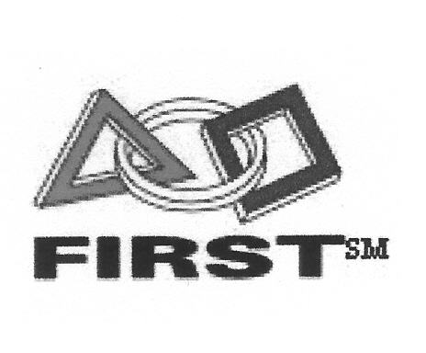Kingman Robotics Team 60

P.O. Box 6492 Kingman, AZ 86402 * Fax (928) 692-6418

**George Williams – Industry Mentor 279-3824** george@laron.com

13 October 2013

[Recipient Name]

[Title]

[Company Name]

[Street Address]

[City, ST ZIP Code]

Dear [Recipient Name]:

My name is Joshua Schanaman and I am part of the engineering program and club called FIRST Robotics created and founded by none other than entrepreneur Dean Kamen.

For Inspiration and Recognition of Science and Technology, or FIRST, allows us, high school level students, to build robots designed to complete a new task every year. Each year we struggle with a new game for both FTC (First Tech Challenge) and FRC (First Robotics Competition). FIRST is an amazing program. Although this program is amazing, we do require funds to operate.

We are graciously asking for your sponsorship to assist us in our continuation in this program. We have begun the FTC season and already started using our reserve funds to help purchase materials and register for this year’s competitions. Team 60 Robotics from Kingman, Arizona would like to ask for your sponsorship.

Every robot we build has a display for the sponsors and we have a sponsor banner which displays our business sponsors. As our robot travels and competes your business name can be viewed by the audiences at these competitions as well as publicized along with our robot. These competitions have been on the news and broadcasted worldwide.

For more information on us visit roboticsteam60.weebly.com or for more information on FIRST visit usfirst.org

Sincerely,